**Generating Test Cases**

A test case is a set of test inputs, execution conditions, and expected

results developed for a particular objective: to exercise a particular

program path or verify compliance with a specific requirement, for

example.

The purpose of a test case is to identify and communicate conditions that

will be implemented in test. Test cases are necessary to verify successful

and acceptable implementation of the product requirements (use cases).

We will describe a three-step process for generating test cases from a fully detailed

use case:

1. For each use case, generate a full set of use-case scenarios.

2. For each scenario, identify at least one test case and the conditions

that will make it "execute."

3. For each test case, identify the data values with which to test.

**ATM machine use case**

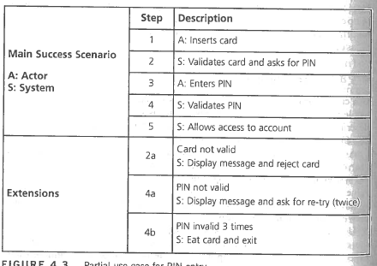

1. **Scenarios**

|  |  |  |
| --- | --- | --- |
| 1 | Account access given | 1, 2, 3, 4, 5, |
| 2 | Invalid Card | 1,2,2a |
| 3 | Frist pin invalid, second valid | 1,2,3,4,4a,4,5 |
| 4 | First and second pin invalid, 3rd valid | 1,2,3,4,4a,4,4a,4,5 |
| 5 | 3 pins invalid | 1,2,3,4,4a4,4a,4,4b |

1. **Identify Test Conditions**

|  |  |  |  |  |  |
| --- | --- | --- | --- | --- | --- |
| **Test ID** | **Scenario** | **Card** | **Pin** | **Expected Result** | **TAG** |
| 1 | 1.Account access given | V | V | Account access given | A |
| 2 | 2.Invalid Card | I | n/a | Display message and reject card | B |
| 3 | 3.Frist pin invalid, second valid | V | I,V | Display message and ask to retry,  Account access given | C |
| 4 | 4.First and second pin invalid, 3rd valid | V | I,I,V | Display message and ask to retry,  Display message and ask to retry,  Account access given | D |
| 5 | 5.3 pins invalid | V | I,I,I | Display message and ask to retry,  Display message and ask to retry,  Eat card and exit | E |

1. **Generate Test Cases**

|  |  |  |  |
| --- | --- | --- | --- |
| **Test case** | **Description** | **Expected result** | **Tags covered** |
| 1 | Valid card 110044563  Valid pin 1111 | Account access given | A |
| 2 | Invalid Card 9999999999 | Error message, Card rejected. | B |
|  |  |  |  |